MC900020810[1]

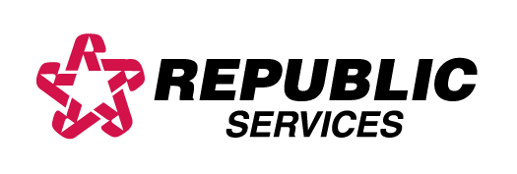

**REPUBLIC Services will be observing the following holiday schedule this season.**

**Thanksgiving 11/27/14** - In observance of the Thanksgiving Holiday, our offices will be closed on Thursday November 27th. **Routes normally scheduled for Thursday will be completed on Friday, and Friday routes will be completed on Saturday November 29th** Please remember to have your waste properly contained at the curb by 6:00 a.m. on the re-scheduled morning of service. Services will return to the normal schedule on Monday December 1st. Monday, Tuesday and Wednesday routes will not be affected.

**Christmas 12/25/14** - In observance of the Christmas Holiday, our offices will be closed on Thursday December 25th. **Routes normally scheduled for Thursday will be completed on Friday, and Friday routes will be completed on Saturday December 27th.** Please remember to have your waste properly contained at the curb by 6:00 a.m. on the re-scheduled morning of service. Services scheduled for Monday, Tuesday, and Wednesday will not be affected. Please see the **New Year’ Day** information below for the following week.

**New Year’s Day 01/01/15** – In observance of the New Year’s Holiday, our offices will be closed on Thursday January 1st. **Routes normally scheduled for Thursday will be completed on Friday and Friday routes will be completed on Saturday January 3rd 2015.** Please remember to have your waste properly contained at the curb by 6:00 a.m. on the re-scheduled morning of service. Services scheduled for Monday, Tuesday and Wednesday will not be affected. All routes will return to their normal schedule the week of January 5th 2015.

***Republic Services would like to thank all of our valued customers and extend our “Warmest Holiday Wishes” to the communities that we take great pride in servicing!***

MC900020810[1]